Acceptance tests   
Acme-Rookies v1.

|  |  |
| --- | --- |
| Development team | |
| **Identifier** | G4 |
| **Members** | Calzado Llamas, Ángel Manuel  Ríos Zea, Alberto  Borge Sánchez, Santiago  Núñez Arenas, Agustín  Navarro Cruz, Raúl  Souto Villegas, Jose Antonio |
| **Testing team** | |
| **Identifier** | G11 |
| **Members** | Ruíz Pliego, Fernando Manuel  Nolé Anguita, Antonio  Jiménez Vega, María  García Gallego, Julia  Calle González, Álvaro |
| **Indexing data** | |
| **Test designers** | Calzado Llamas, Ángel Manuel  Ríos Zea, Alberto  Borge Sánchez, Santiago  Núñez Arenas, Agustín  Navarro Cruz, Raúl  Souto Villegas, José Antonio |
| **Testers** |  |
| **Notes** | It’s import to repopulate the database after every test, in order to avoid some errors. |

## Índice

Use case UC01 Register as a Company 2

Use case UC02 Unauthenticated actor lists published positions and views their associated companies 5

Use case UC03 An actor lists each company’s position 6

Use case UC04 Actor not authenticated use filter 8

Use case UC05 Register as a Rookie 10

Use case UC06 Edit personal data 14

Use case UC07 Company creates position 16

Use case UC08 Company edits and deletes position 19

Use case UC09 Company creates a problem 22

Use case UC10 Company edits and deletes a problem 24

Use case UC11 Company associates problems with positions 27

Use case UC12 Administrator creates a new aadministrator 30

Use case UC13 Administrator access to dashboard 33

Use case UC14 Administrator edits configuration 34

Use case UC15 Rookie creates a curriculum 36

Use case UC16 Rookie edits or deletes a curriculum 38

Use case UC17 Rookie uses his/her finder 42

Use case UC18 Actor creates social profile 45

Use case UC19 Actor edits and deletes social profile 47

Use case UC20 Actor sends message 51

Use case UC21 Actor deletes message 54

Use case UC22 Administrator sends broadcast message 57

Use case UC23 Administrator bans or unbans spammer 60

Use case UC24 Rookie applies position 62

Use case UC25 Rookie edits application 64

Use case UC26 Auditor assigns positions 66

Use case UC27 Auditor creates audits 68

Use case UC28 Auditor edits and deletes audits 71

Use case UC29 Administrator notifies new changes 73

Use case UC30 Administrator creates a new auditor 75

Use case UC31 Actor not authenticated sees all the items of the system 78

Use case UC32 Actor not authenticated sees all the providers of the system 80

Use case UC33 Provider creates item 82

Use case UC34 Provider edits item 85

Use case UC35 Provider creates sponsorship 88

Use case UC36 Provider edits and deletes sponsorship 91

Use case UC37 Administrator makes a decision for application 94

Additional tests 97

#### Use case UC01 Register as a Company

#### Description

### An actor who is **not authenticated** must be able to register to the system as company. He or she should hit on “Register as a Company” button on the Welcome page. Then he or she will fill the inputs (obligatory almost) and hits on “Save” button. It will be redirected to the Login page.

#### Access

### - Hit on “Register as a Company” button

### 

### 

### 

### 

### 

### 

### 

### 

### 

### 

### 

#### Tests

|  |  |
| --- | --- |
| Test #1 | |
| **Description** | The form must be filled in with the following data:  **Commercial Name**: CommercialName1  **Name:** Name1  **Surnames:** Surnames1  **VAT:** 987462  **Email:** email1@gmail.com  **Username**: companyusername  **Password**: companypassword  **Confirm** **password**: companypassword  **Accept terms and conditions**  **Holder Name:** holdername1  **Make:** make1  **Number:** 1111222233334444  **Expiration Month:** 12  **Expiration Year:** 2020  **CVV:** 123 |
| **Expected** | The system must redirect to the Login page. |
| **Outcome** |  |
| **Notes** |  |

### 

### 

### 

### 

### 

### 

|  |  |
| --- | --- |
| Test #2 | |
| **Description** | Click on the checkbox of Terms and Conditions and leave empty every other field of the form. Then click on the “Save” button. |
| **Expected** | The system must redirect to the form and show you some errors in requested fields. |
| **Outcome** |  |
| **Notes** |  |

### 

### 

### Use Case UC02 Unauthenticated actor lists published positions and views their associated companies

#### Description

An actor who is **not authenticated** access to position list and then clicks on the desired **company.**

#### Access

* On the welcome page, hit in the **position list** button.

### 

#### Tests

|  |  |
| --- | --- |
| Test #1 | |
| **Description** | The button “company” shows the company that has created that position. |
| **Expected** | When the actor clicks the “company” button it shows the position that has been created by the company |
| **Outcome** |  |
| **Notes** |  |

### Use Case UC03 An actor lists each company’s positions

#### Description

An actor who is **authenticated** can access to companies list and then list the **positions of each company.**

#### Access

### On the welcome page, hit in the **companies list** button then select whose positions you want to list by clicking on the the **positions** button next to each company.

### 

#### Tests

|  |  |
| --- | --- |
| Test #1 | |
| **Description** | The button “position” shows the positions that has been created by that company. |
| **Expected** | When the actor clicks the “position” button it lists the positions that has been created by the company |
| **Outcome** |  |
| **Notes** |  |

|  |  |
| --- | --- |
| Test #2 | |
| **Description** | Click on pagination to see if it works. |
| **Expected** | When the actor clicks on “2” it should list more positions of the same company. |
| **Outcome** |  |
| **Notes** |  |

### 

### 

### Use Case UC04 Actor not authenticated uses filter

#### Description

An actor who is **not authenticated** access to position list and fill the filter’s gaps to make a filter about: title, description, profile, skills and technologies (**keyword**) and **commercial name**

#### Access

* On the welcome page, hit in the **position list** button.

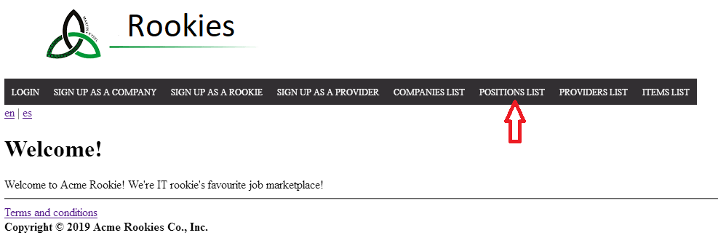

#### Tests

|  |  |
| --- | --- |
| Test #1 | |
| **Description** | The filter form must be filled in with the following data: **commercialName:** Russel |
| **Expected** | The system back to the same page but now with the position/s that match with the filter. In this case with the **comercialName** |
| **Outcome** |  |
| **Notes** | Note that the column “Company” refers to the attribute “Comercial Name” of the companies. |

|  |  |
| --- | --- |
| Test #2 | |
| **Description** | Probe that the pagination works. Hit on the next page |
| **Expected** | The system back to the same page with the second page like this: |
| **Outcome** |  |
| **Notes** |  |

### Use case UC05 Register as a Rookie

#### Description

### An actor who is **not authenticated** must be able to register to the system as rookie. He or she should hit on “Register as a Rookie” button on the Welcome page. Then he or she will fill the inputs (obligatory almost) and hits on “Save” button. It will be redirected to the Login page.

#### Access

### - Hit on “Register as a Rookie” button

### 

### 

### 

### 

### 

### 

### 

### 

### 

### 

#### 

#### Tests

|  |  |
| --- | --- |
| Test #1 | |
| **Description** | The form must be filled in with the following data:  **Name:** NameRookie1  **Surnames:** SurnamesRookie1  **VAT:** 2567023  **Email:** emailrookie1@gmail.com  **Username**: rookieusername  **Password**: rookiepassword  **Confirm** **password**: rookiepassword  **Accept terms and conditions**  **Holder Name:** holdername1  **Make:** make1  **Number:** 1111222233334444  **Expiration Month:** 12  **Expiration Year:** 2020  **CVV:** 123  Then click the “Save” button |
| **Expected** | The system must redirect to the Login page. |
| **Outcome** |  |
| **Notes** |  |

### 

|  |  |
| --- | --- |
| Test #2 | |
| **Description** | Fill the form with the same data in the Test #1. Change the username to: **<script>alert(‘Hola Mundo’)</script>** . Click the “Save” button. |
| **Expected** | The system must redirect to the form and show these errors about insecure html and the size of username. |
| **Outcome** |  |
| **Notes** |  |

### 

### Use case UC06 Edit personal data

#### Description

### Every **authenticated** actor must be able to edit his or her personal data. The actor should hit on “Profile” button and the hit on “Edit”. Now he or she can edit his or her data and save hitting on “Save” button.

#### Access

### - Login as Auditor: auditor1/auditor1

### - Hit on “Profile” button

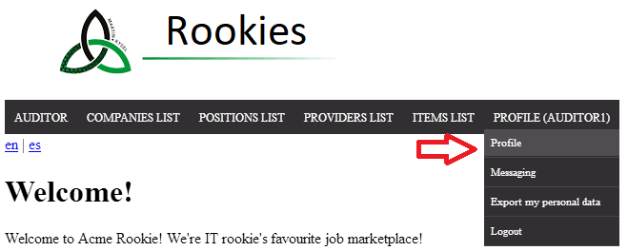

### - Hit on “Edit” button

### 

### 

### 

#### Tests

|  |  |
| --- | --- |
| Test #1 | |
| **Description** | Change the field name to: Antonio. Then click on the “Save” button. |
| **Expected** | The system must redirect to Profile name and you can see your name changed correctly. |
| **Outcome** |  |
| **Notes** |  |

### 

### 

|  |  |
| --- | --- |
| Test #2 | |
| **Description** | Click on F12 button on your keyboard to see HTML view. Then change the “id”, that you can see in the photo, to another “id” of an auditor*. Finally click “Save” button. |
| **Expected** | The system must redirect to same Edit page with an error like in the photo: |
| **Outcome** |  |
| **Notes** | *You should look for an auditor “id” in your database using MySQL Workbench. Don’t use the same id that registered Auditor. |

### Use Case UC07 Company creates position

#### Description

An actor who is authenticated as a company must be able to create a position.

#### Access

* Login as company1/company1.
* Click on “List his/her Position” (english version) or “Lista de sus Posiciones” (spanish version).

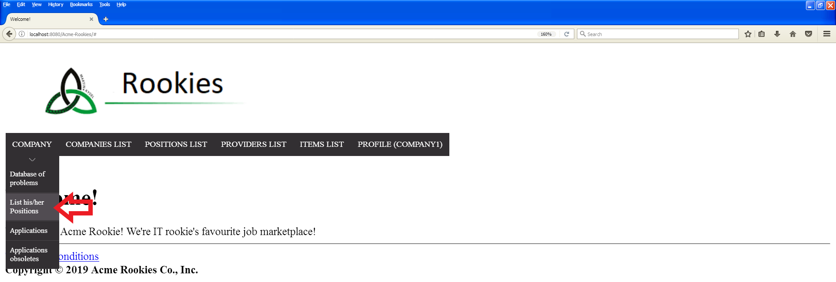

* Click on “create” or “crear” link.

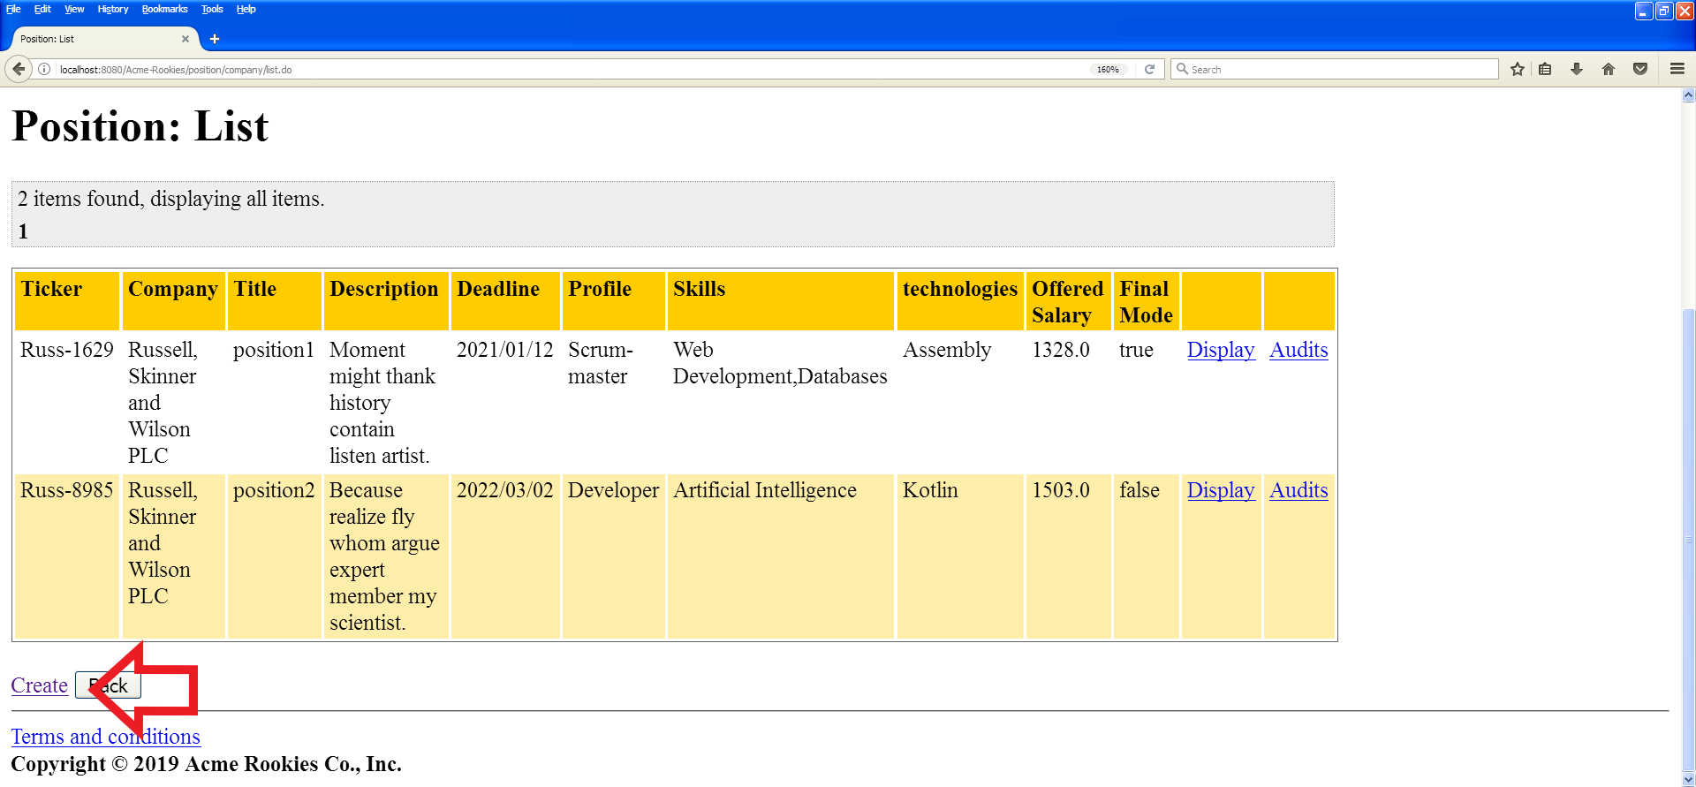

#### 

#### Tests

|  |  |
| --- | --- |
| Test <#1> | |
| **Description** | The form must be filled in with the following data: **Title**: test, **Description**: test, **Deadline**: 2020/12/21, **Profile**: Developer, **Skills**: Artificial Intelligence, **Technologies**: ML , **Offereded Salary**: 1700, **Final Mode**: No Final. |
| **Expected** | The system back to the list of positions and you will be able to see your new position created with the same information you filled. |
| **Outcome** |  |
| **Notes** |  |

|  |  |
| --- | --- |
| Test <#2> | |
| **Description** | The form must be filled in with the following data: **Title**: test, **Description**: test, **Deadline**: 2018/12/21 (past date), **Profile**: Developer, **Skills**: Artificial Intelligence, **Technologies**: ML , **Offereded Salary**: 1700, **Final Mode**: No Final. |
| **Expected** | The system back to create form with an “Unexpected Error”. |
| **Outcome** |  |
| **Notes** |  |

### Use Case UC08 Company edits and deletes position

#### Description

An actor who is authenticated as a company must be able to edit and delete a position.

#### Access

* Login as company1/company1.
* Click on “List his/her Position” (english version) or “Lista de sus Posiciones” (spanish version).



* Click on “display” or “mostrar” link on the position with ticker Russ-8985.

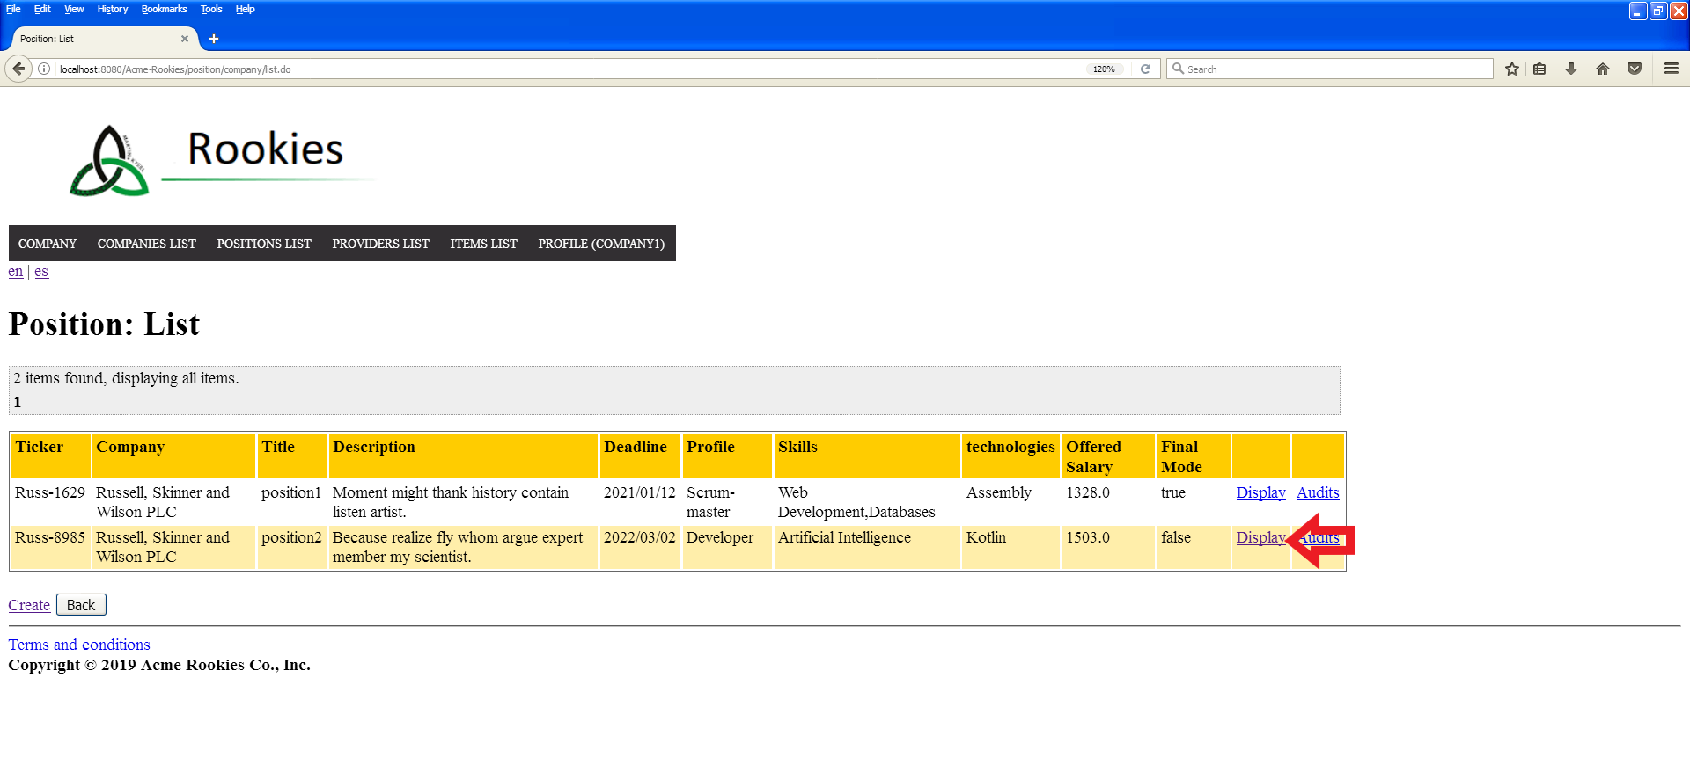

* Click on “edit” or “editar” button.

#### 

#### Tests

|  |  |
| --- | --- |
| Test <#1> | |
| **Description** | The form must be filled in with the following data: **Title**: test, **Description**: Because realize fly whom argue expert member my scientist., **Deadline**: 2022/03/02, **Profile**: Developer, **Skills**: Artificial Intelligence, **Technologies**: Kotlin, **Offereded Salary**: 1503.0, **Final Mode**: No Final. |
| **Expected** | The system back to the list of positions and you will be able to see your position edited with the same information you filled. |
| **Outcome** |  |
| **Notes** |  |

|  |  |
| --- | --- |
| Test <#2> | |
| **Description** | The form must be filled in with the following data: **Title**: null, **Description**: null, **Deadline**: null, **Profile**: null, **Skills**: null, **Technologies**: null, **Offereded Salary**: null, **Final Mode**: No Final. |
| **Expected** | The system back to edit form with some domain errors. |
| **Outcome** |  |
| **Notes** |  |

### Use case UC09 Company creates a problem

#### Description

Every An actor who is **authenticated** as a Company must be able to create a problem. The actor should hit on “Database of problems” button to see the list of his or her problems. Then he or she should click on the “Create” button to see the form to create a problem. Finally, he or she should fill the form and click on “Save” button.

#### Access

- Login as Company: company1/company1

- Hit on “Database of problems” button

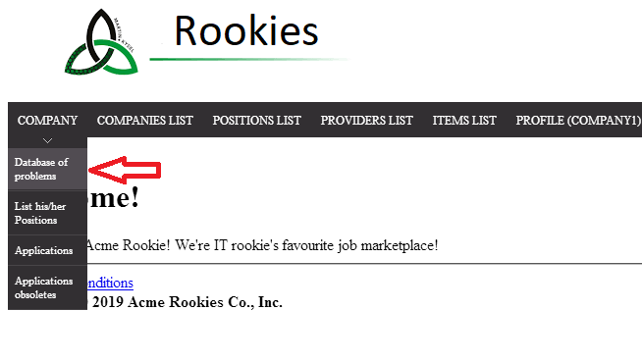

- Hint on “Create” button.

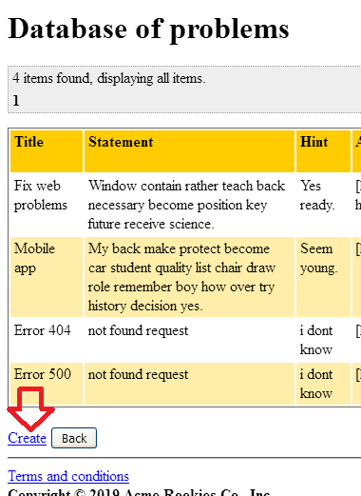

Tests

|  |  |
| --- | --- |
| Test #1 | |
| **Description** | The form must be filled in with the following data:  **Title:** Title1  **Statement:** Statement1  **Attachments:** https://google.com  **Final Mode:** No final  Click the “Save” button. |
| **Expected** | The system must redirect to the “Database of problems” view. Now you can see your Problem created correctly. |
| **Outcome** |  |
| **Notes** |  |

|  |  |
| --- | --- |
| Test #2 | |
| **Description** | Change the language to Spanish. Then click again on the “Base de datos de problemas” button. Check that all the information that is not about a problem is in Spanish. |
| **Expected** | All the information should be in Spanish except the information within in the table. |
| **Outcome** |  |
| **Notes** |  |

### Use case UC10 Company edits and deletes a problem

#### Description

An actor who is **authenticated** as a Company must be able to edit and delete a problem. The actor should hit on “Database of problems” button to see the list of his or her problems. Then he or she should click on the “Display” button of a problem with ‘false’ Final Mode. He or she should click on “Edit” button to see the information that it is be able to edit and a “Delete” button to delete the problem.

#### Access

- Login as Company: company1/company1

- Hit on “Database of problems” button



- Hint on “Display” button. (Final Mode should be false)

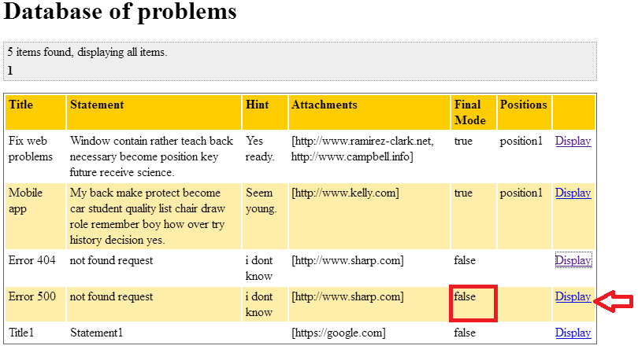

- Hint on Edit button

#### 

#### Tests

|  |  |
| --- | --- |
| Test #1 | |
| **Description** | Change the field **title** to: ErrorAcceptanceTest.  Then click on the “Save” button. |
| **Expected** | The system must redirect to the “Database of problems” view. Now you can see your Problem edited correctly. |
| **Outcome** |  |
| **Notes** |  |

|  |  |
| --- | --- |
| Test #2 | |
| **Description** | Click on F12 button on your keyboard to see HTML view. Then change the “id”, that you can see in the photo, to another “id” of another unknown id (123456). Finally click “Delete” button. |
| **Expected** | The system must redirect you to a “Invalid URL” view. |
| **Outcome** |  |
| **Notes** |  |

Use case UC11 Company associates problems with positions

#### Description

An actor who is **authenticated** as a Company must be able to associate problem with position. The actor should hit on “Database of problems” button to see the list of his or her problems. Then he or she should click on the “Display” button of a problem with ‘true’ Final Mode. He or she should click on “Add position” button and he or she will be redirected to the position be able to add. Finally, he or she should hint on the “Add position” button of the position that she or he wants to associate with.

#### Access

- Login as Company: company1/company1

- Hit on “Database of problems” button



- Hint on “Display” button. (Final Mode should be true)

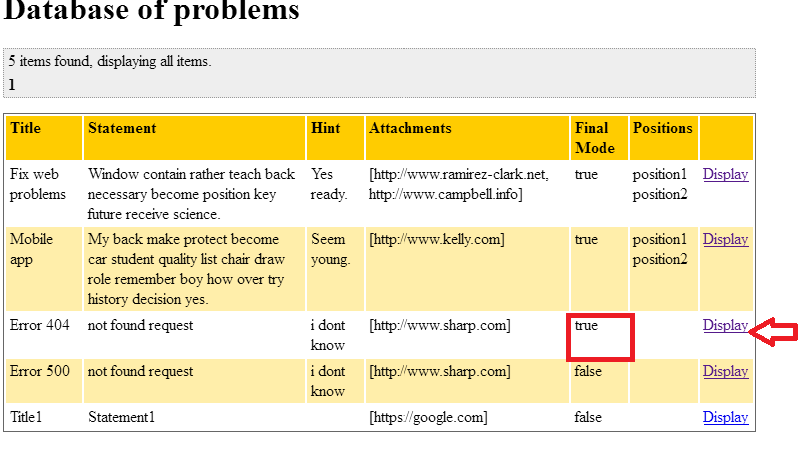

- Hint on “Add position” button

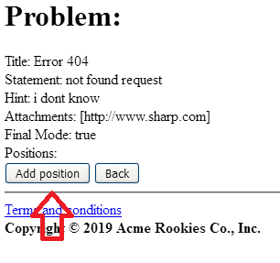

#### Tests

|  |  |
| --- | --- |
| Test #1 | |
| **Description** | When you are seeing the list of available positions to associate with the problem, click on the “Add position” button, of the position 2 for example. |
| **Expected** | The system must redirect you to the list of the position available to associate with the same problem. You should go the “Database of problems” again and now you can see that the problem it’s associated with the position. |
| **Outcome** |  |
| **Notes** |  |

|  |  |
| --- | --- |
| Test #2 | |
| **Description** | You should write this URL when you are seeing the list of available positions to associate with the problem: localhost:8080/Acme-Rookies/ problem/company/addPositionPost.do?positionId=**4578**&problemId=**4605**  Change the marked Id’s for an unknown number, for example: 123456 and 789101. |
| **Expected** | The system must redirect you to a “Invalid URL” view. |
| **Outcome** |  |
| **Notes** |  |

### 

### Use Case UC12 Administrator creates a new administrator

#### Description

An actor who is authenticated as a administrator must be able create user accounts for new administrators.

#### Access

* Login as admin/admin.
* Click on “Sign up administrator” (english version) or “Registrar administrador” (spanish version).

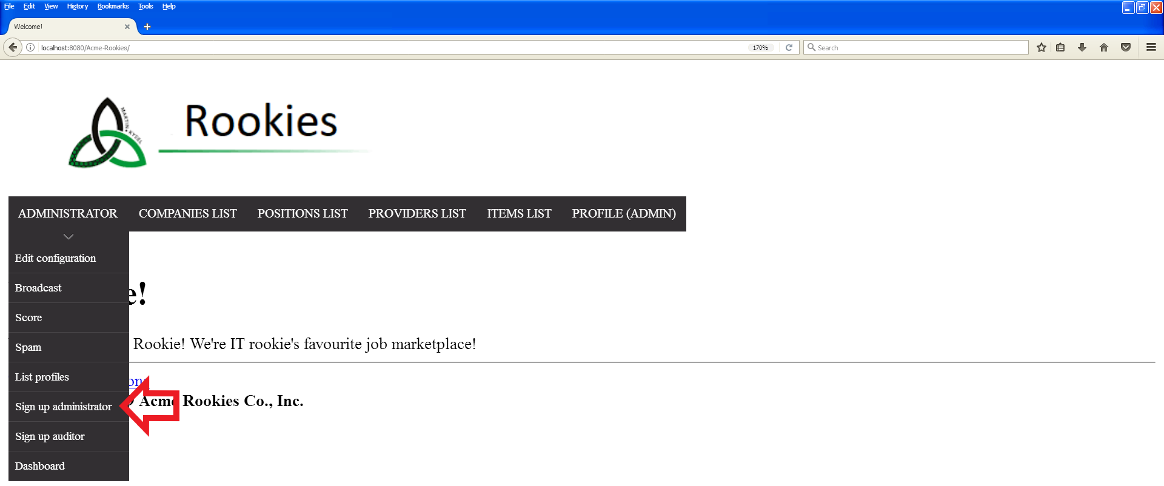

#### Tests

|  |  |
| --- | --- |
| Test <#1> | |
| **Description** | The form must be filled in with the following data: **Name**: Rubén Antonio, **Surnames**: Ramírez Rojas, **VAT**: 9056325, **Photo**: null, **Email**: [rubantramroj@gmail.com](mailto:rubantramroj@gmail.com), **Phone**: +34 678905413, **Address**: null, **Username**: adminTest, **Password**: adminTest, **Confirm Password**: adminTest, **Holder Name**: Rubén Antonio Ramírez Rojas, **Make**: Visa, **Number**: 4556737586899855, **Expiration Month**: 11, **Expiration Year**: 2021, **CVV**: 904, **I read and accept terms and conditions**. |
| **Expected** | The system back to welcome page. |
| **Outcome** |  |
| **Notes** | It’s import to repopulate the database in order to avoid repetitions in the attributes. |

|  |  |
| --- | --- |
| Test <#2> | |
| **Description** | The form must be filled in with the following data: **Name**: null, **Surnames**: null, **VAT**: null, **Photo**: null, **Email**: null, **Phone**: null, **Address**: null, **Username**: null, **Password**: null, **Confirm Password**: null, **Holder Name**: null, **Make**: null, **Number**: null, **Expiration Month**: null, **Expiration Year**: null, **CVV**: null, **I read and accept terms and conditions**. |
| **Expected** | The system back to create form with some domain errors. |
| **Outcome** |  |
| **Notes** |  |

### Use Case UC13 Administrator access to dashboard

#### Description

An actor who is authenticated as a administrator must be able to show a dashboard with usage statistic.

#### Access

* Login as admin/admin.
* Click on “Dashboard”

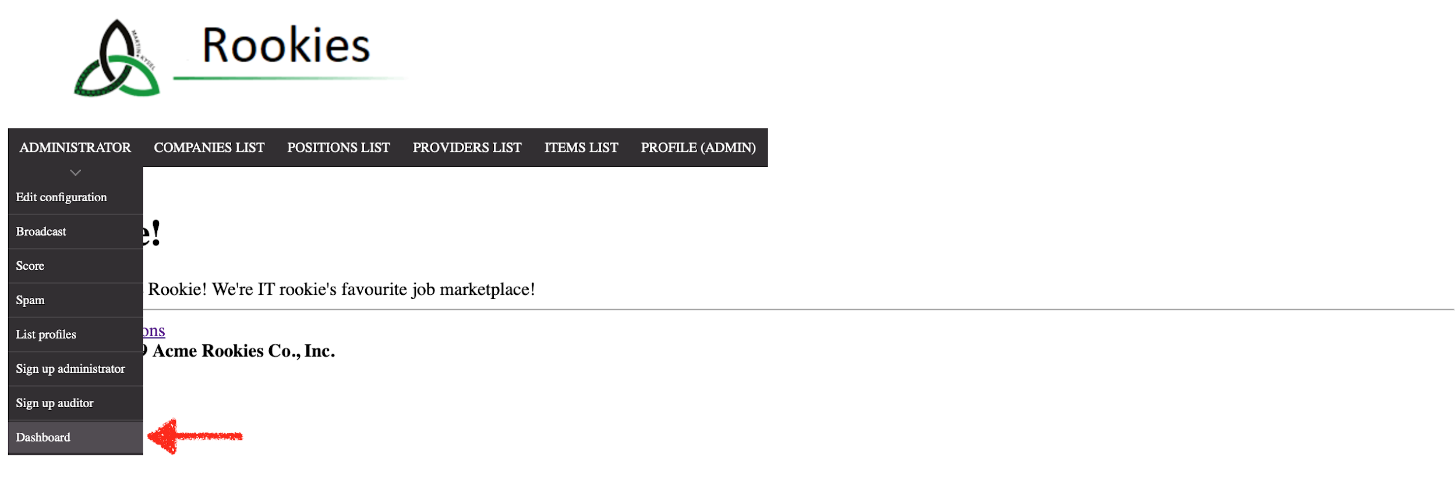

#### Tests

|  |  |
| --- | --- |
| Test <#1> | |
| **Description** | The administrator shows the dashboard display with usage statistic of the system. |
| **Expected** | Dashboard display. |
| **Outcome** |  |
| **Notes** |  |

### Use Case UC14 Administrator edit configuration

#### Description

An actor who is authenticated as a administrator must be able edit fields of configuration.

#### Access

* Login as admin/admin.
* Click on “Edit configuration”

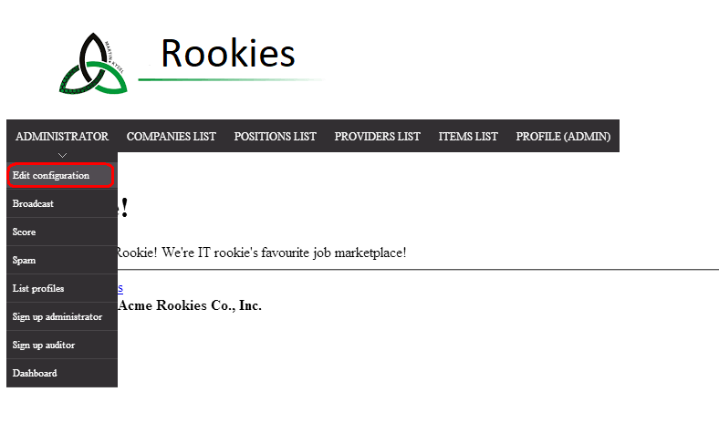Tests

|  |  |
| --- | --- |
| Test <#1> | |
| **Description** | When you are seeing “Edit configuration” view, change the value of **Finder Time** to “3”.  Click the save button |
| **Expected** | The system save the new value. |
| **Outcome** |  |
| **Notes** |  |

|  |  |
| --- | --- |
| Test <#2> | |
| **Description** | When you are seeing “Edit configuration” view, change the value of **Finder Result** to “twenty”.  Click the save button |
| **Expected** | The system must show an error due to the value of digit is invalid |
| **Outcome** |  |
| **Notes** |  |

### 

### Use Case UC15 Rookie creates a curriculum

#### Description

An actor who is authenticated as a rookie must be able create a curriculum.

#### Access

* Login as rookie1/rookie1.
* Click on “Curriculum”.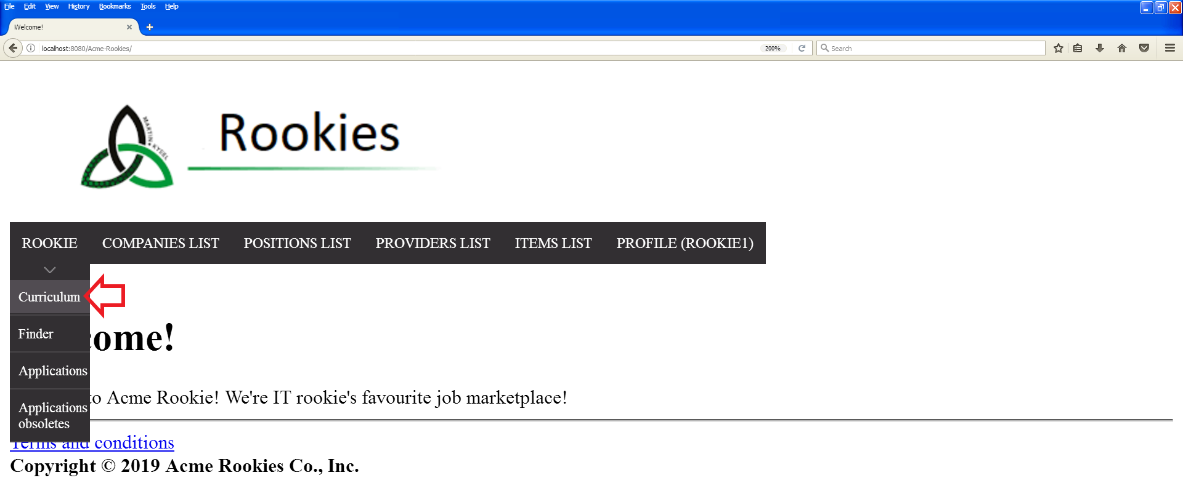
* Click on “Create” (english version) or “crear” (spanish version).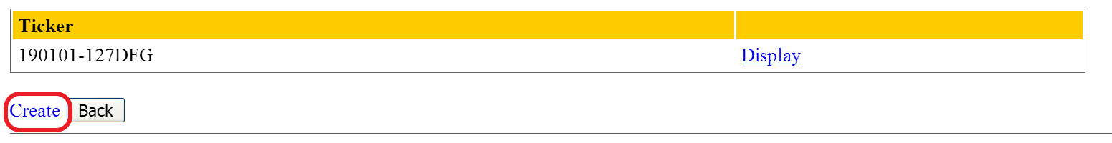

#### 

#### Tests

|  |  |
| --- | --- |
| Test <#1> | |
| **Description** | The form must be filled in with the following data: **Statement:** test,  **Phone**: +34 678905413, **Link GitHub profile**: http://example.com, **Link LinkedIn profile**: <http://example.com> . |
| **Expected** | The system back to curriculum list with two curriculums. |
| **Outcome** |  |
| **Notes** |  |

|  |  |
| --- | --- |
| Test <#2> | |
| **Description** | The form must be filled in with the following data: **Statement:** null,  **Phone**: null, **Link GitHub profile**: null, **Link LinkedIn profile**: null . |
| **Expected** | The system back to create form with some domain errors. |
| **Outcome** |  |
| **Notes** |  |

### Use Case UC16 Rookie edist or deletes a curriculum

#### Description

An actor who is authenticated as a rookie must be able edit or delete a curriculum.

#### Access

* Login as rookie1/rookie1.
* Click on “Curriculum”.
* Click on “Create” (english version) or “crear” (spanish version).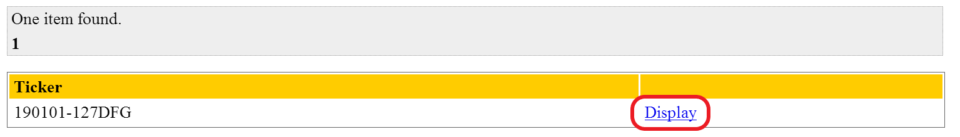
* Click on the second page link of miscellaneous datas list.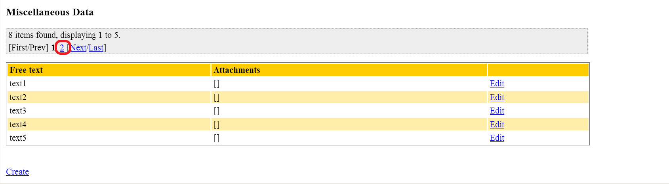
* Click on “Edit” or “Editar” link of the second miscellaneous data of the second page.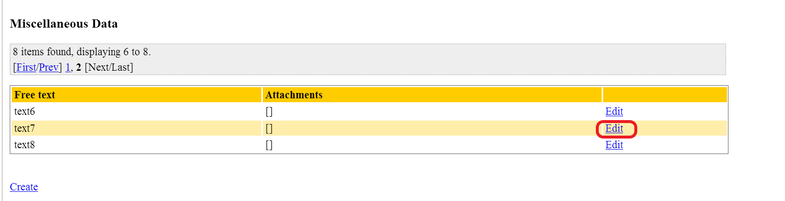

#### Tests

|  |  |
| --- | --- |
| Test <#1> | |
| **Description** | The form must be filled in with the following data: **Text**: test, **Attachments**: <http://example.com> . |
| **Expected** | The system back to curriculum`s display and now, you can see de miscellaneous data edited in the list. |
| **Outcome** |  |
| **Notes** |  |

|  |  |
| --- | --- |
| Test <#2> | |
| **Description** | The form must be filled in with the following data: **Text**: test, **Attachments**: Esto no es un link |
| **Expected** | The system back to create form with an “Invalid Url/s (Make sure it is url/s and you put a comma between them without spaces)”. |
| **Outcome** |  |
| **Notes** |  |

### 

### 

### 

### 

### 

### Use Case UC17 Rookie uses his/her Finder

#### Description

An actor who is authenticated as **rookie** hit in the Finder’s button to make a new match or see the previous.

#### Access

* On the log page: rookie1/rooke1 (username/password)
* Go to his/her finder

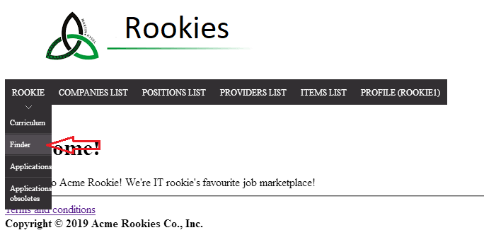

#### 

#### 

#### Tests

|  |  |
| --- | --- |
| Test #1 | |
| **Description** | The filter form must be filled in with the following data: **Minimum Salary:** 0, **Maximum Salary:** 1000 and hit in search’s button. |
| **Expected** | The system back to the same page but now with the position/s that match with the finder. |
| **Outcome** |  |
| **Notes** | Note that the column “Company” refers to the attribute “Comercial Name” of the companies. |

|  |  |
| --- | --- |
| Test #2 | |
| **Description** | Try to break the security doing post hacking. Inspect the element (normally push F12 on the keyboard) and modify the finder id with the finder id of another actor.    Then, close the panel and push the search button. |
| **Expected** | The system back to the same page with a message error: |
| **Outcome** |  |
| **Notes** | We are not sure about if the id used as **finderId** of another rookie can be the same for you. We recommend you search another id that you know that is another finderId. |

### 

### Use Case UC18 Actor creates social profile

#### Description

An actor who is authenticated must be able create social profiles.

#### Access

* Login as rookie1/rookie1.
* Click on “Profile” button

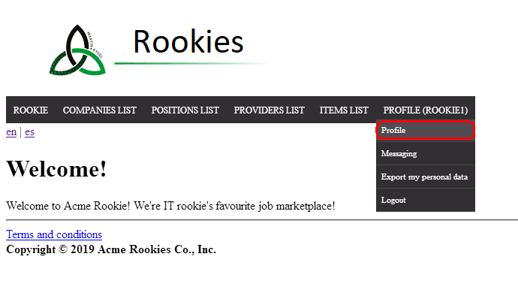

* Click on “Social Profile” button

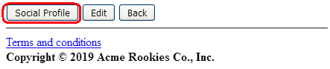

* Click on “Create” button

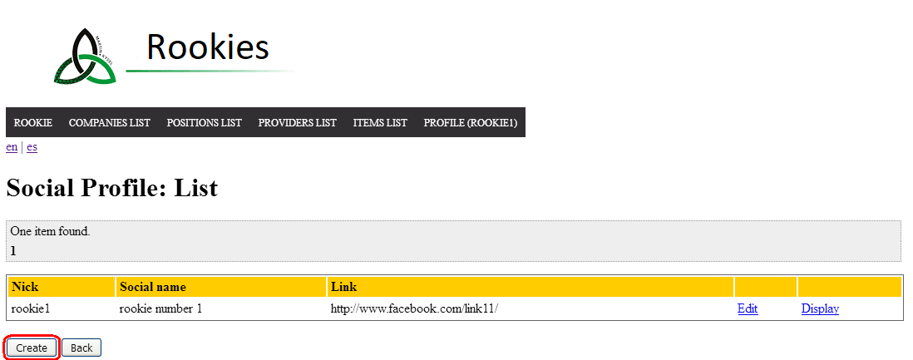

Tests

|  |  |
| --- | --- |
| Test <#1> | |
| **Description** | When you are seeing “Create social profile” view, fill the form fields with this data:  **Nick:** nickExample  **Social Name:** socialNameExample  **Link:** http://linkExample.es  Click the save button |
| **Expected** | The system must redirect you to the list of social profiles. Now yor can see the new social profile created correctly. |
| **Outcome** |  |
| **Notes** |  |

|  |  |
| --- | --- |
| Test <#2> | |
| **Description** | When you are seeing “Create social profile” view, fill the form fields with this data:  **Nick:** nickExample  **Social Name:** socialNameExample  **Link:** bad link  Click the save button |
| **Expected** | The system must show an error due to URL format is invalid |
| **Outcome** |  |
| **Notes** |  |

### 

### Use Case UC19 Actor edits and deletes social profile

#### Description

An actor who is authenticated must be able edit and delete social profiles.

#### Access

* Login as rookie1/rookie1.
* Click on “Profile” button



* Click on “Social Profile” button



* Click on “Edit” button

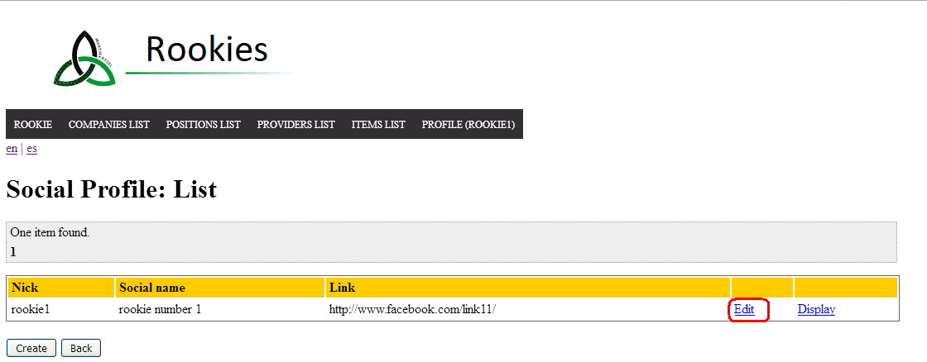

Tests

|  |  |
| --- | --- |
| Test <#1> | |
| **Description** | When you are seeing “Edit social profile” view, change the value of  **Nick** to “r1”  Click the save button |
| **Expected** | The system must redirect you to the list of social profiles. Now yor can see the field of social profile edited correctly. |
| **Outcome** |  |
| **Notes** |  |

|  |  |
| --- | --- |
| Test <#2> | |
| **Description** | When you are seeing “Edit social profile” view, change the value of  **Nick** to blank (empty value).  Click the save button |
| **Expected** | The system must show an error due to this field must not be blank |
| **Outcome** |  |
| **Notes** |  |

|  |  |
| --- | --- |
| Test <#3> | |
| **Description** | When you are seeing “Edit social profile” view, click the “display” button and them, click “delete” button. |
| **Expected** | The system must redirect you to the list of social profiles. Now yor can see that deleted social profile is not in this list. |
| **Outcome** |  |
| **Notes** |  |

### Use Case UC20 Actor sends message

#### Description

An actor who is authenticated must be able send a message to other actor.

#### Access

* Login as company1/company1.
* Click on “Messaging” button

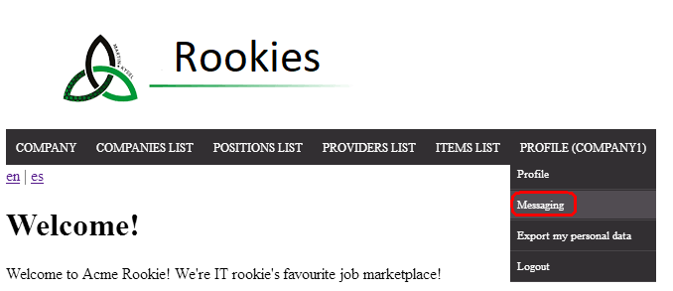

* Click on “New message” button

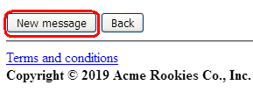

* Select a recipient. Click on “Contact” button. For example, to Melissa.

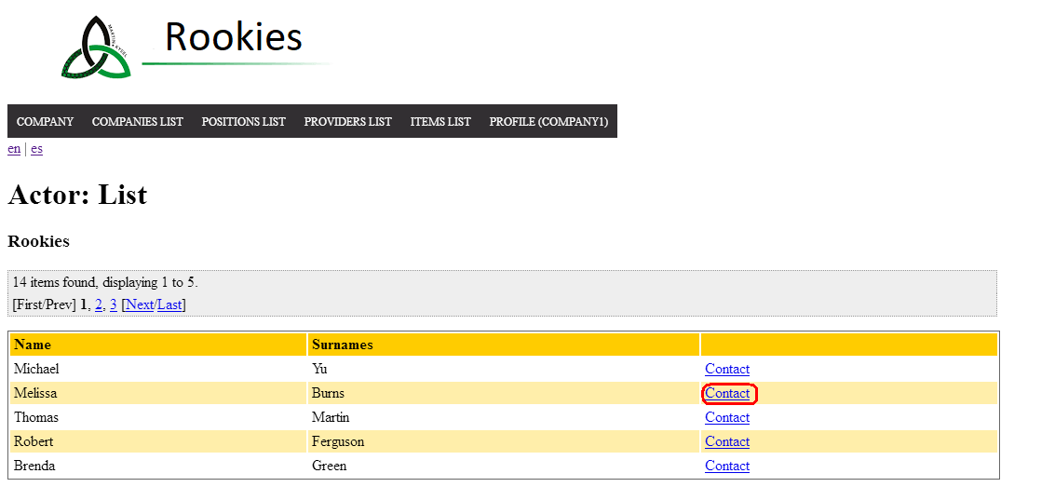

Tests

|  |  |
| --- | --- |
| Test <#1> | |
| **Description** | When you are seeing “Create message” view, fill the form fields with this data:  **Subject:** Message for test  **Body:** Hi Melissa!  **Tags:** EXAMPLE  Click the save button |
| **Expected** | The system must redirect you to the list of messages. Now you can see the new message . |
| **Outcome** |  |
| **Notes** |  |

|  |  |
| --- | --- |
| Test <#2> | |
| **Description** | When you are seeing “Create message” view, fill the form fields with this data:  **Subject:** Message for test  **Body:** Hi Melissa!  **Tags:** NOTIFICATION  Click the save button |
| **Expected** | The system must redirect you to the list of messages. Now you can see the new message, but “NOTIFICATION” is a reserved tag so this field is empty. |
| **Outcome** |  |
| **Notes** |  |

### Use Case UC21 Actor deteles message

#### Description

An actor who is authenticated must be able delete his or her messages.

#### Access

* Login as company1/company1.
* Click on “Messaging” button



* Select a message and click on “Display” button. For example, this:

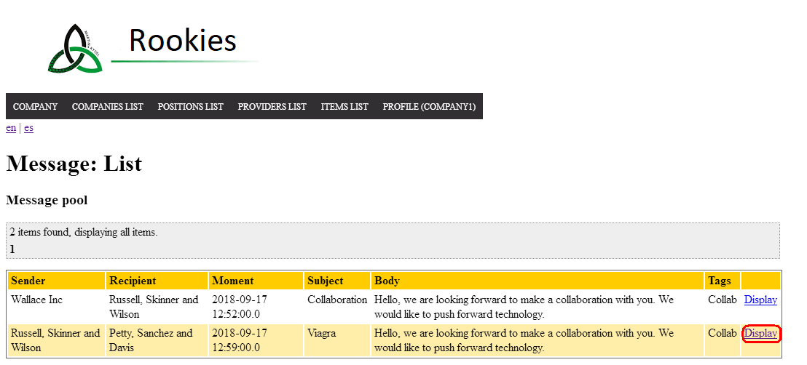

Tests

|  |  |
| --- | --- |
| Test <#1> | |
| **Description** | When you are seeing “Display” view ,click the delete button. |
| **Expected** | The system must redirect you to the list of messages. Now you can see that this message is not in this list. |
| **Outcome** |  |
| **Notes** |  |

|  |  |
| --- | --- |
| Test <#2> | |
| **Description** | When you are seeing “Display” view ,click the delete button with right button of mouse. Then you can see a window for inspect an element.  In this new window change the value of id message to a not-existent value, for example “1” |
| **Expected** | The system must redirect you to a view where says you that this id is not valid. |
| **Outcome** |  |
| **Notes** |  |

### 

### 

### Use Case UC22 Administrator sends broadcast message

#### Description

An actor who is authenticated as administrator must be able send a broadcast message to the rest of actors.

#### Access

* Login as admin/admin.
* Click on “Broadcast” button

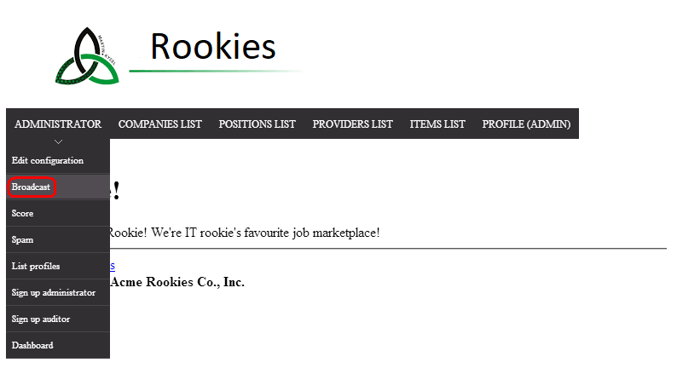

Tests

|  |  |
| --- | --- |
| Test <#1> | |
| **Description** | When you are seeing “Create message” view, fill the form fields with this data:  **Subject:** test  **Body:** This is a test  Click the save button . |
| **Expected** | The system must redirect you to welcome page and the new message is in system list of every actor. |
| **Outcome** |  |
| **Notes** |  |

|  |  |
| --- | --- |
| Test <#2> | |
| **Description** | When you are seeing “Create message” view, fill the form fields with all empty |
| **Expected** | The system must show some errors messages saying that the fields must not be empty |
| **Outcome** |  |
| **Notes** |  |

### Use Case UC23 Administrator bans or unbans spammer

#### Description

An actor who is authenticated as a administrator must be able ban or unban an actor with the spammer flag.

#### Access

* Login as admin/admin.
* Click on “Spam”.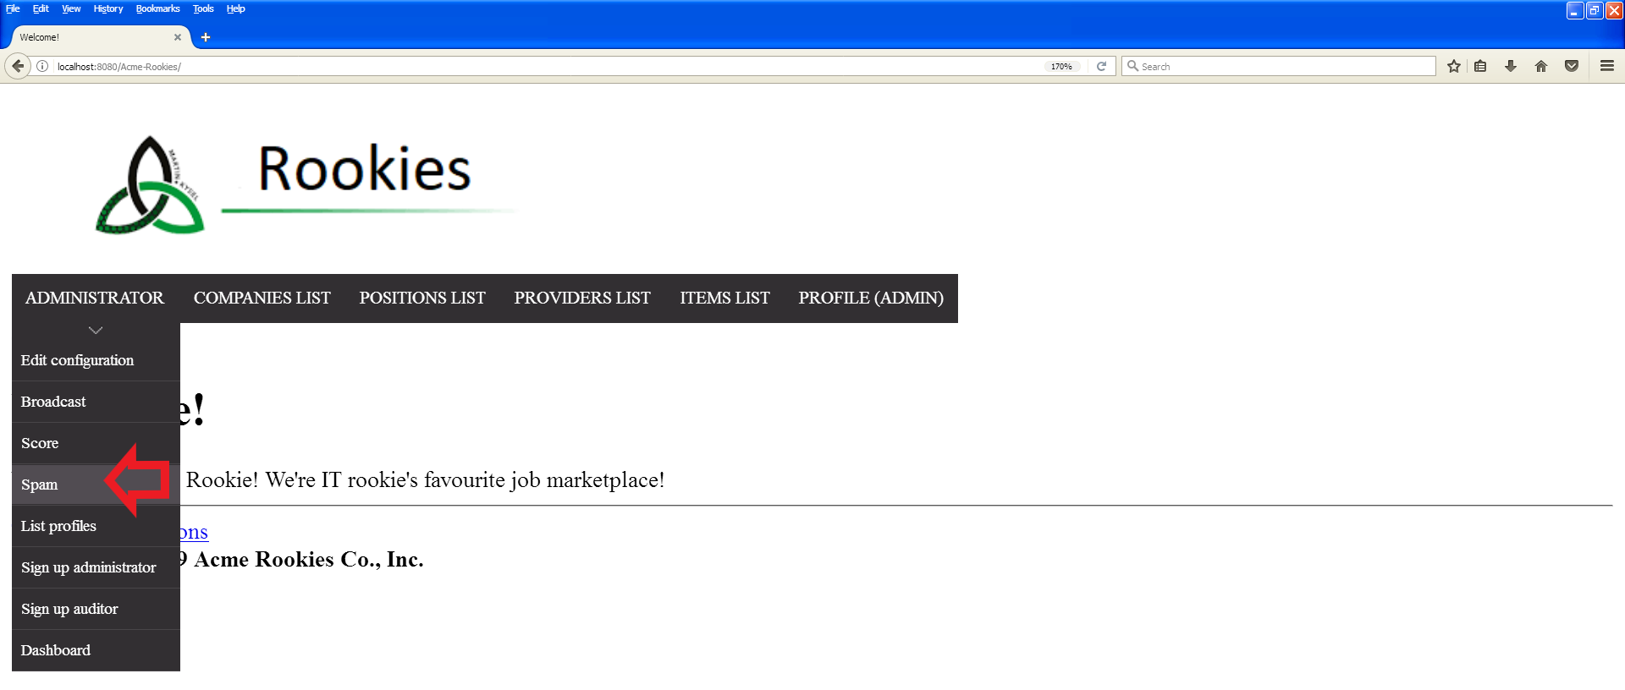
* Click on “Find spammer” (english version) or “Encontrar” (spanish version).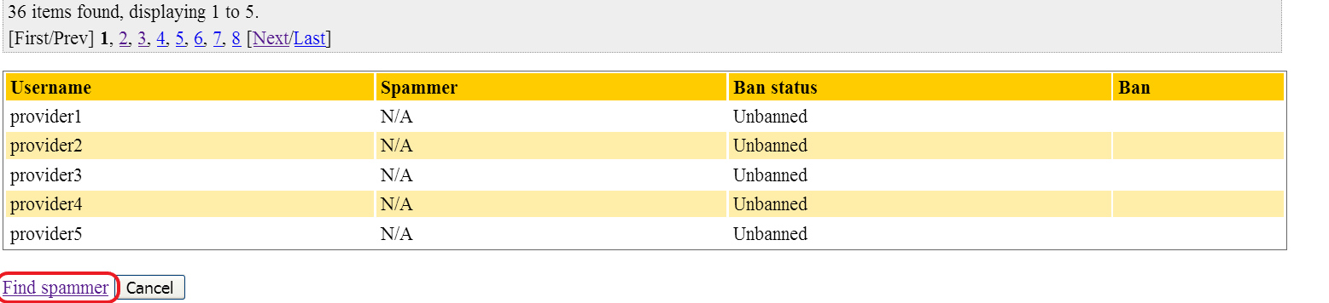
* Click on the link of the third page.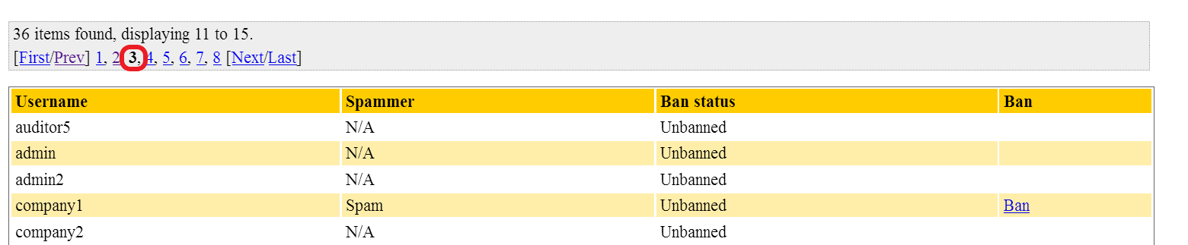

#### 

#### Tests

|  |  |
| --- | --- |
| Test <#1> | |
| **Description** | Ban company1. |
| **Expected** | The system back to the actor list and now allows to unban company1. |
| **Outcome** |  |
| **Notes** | After testing, repopulate the database or unban company1. |

|  |  |
| --- | --- |
| Test <#2> | |
| **Description** | Performs Get hacking on “ban” link with id 71344 (non-existent id). |
| **Expected** | The system returns the Invalid URL page. |
| **Outcome** |  |
| **Notes** |  |

### Use Case UC24 Rookie applies position

#### Description

An actor who is authenticated as a rookie must be able applies a position.

#### Access

* Login as rookie1/rookie1.
* Click on “POSITION LIST” (english version) and “LISTA DE POSICIONES” (spanish version).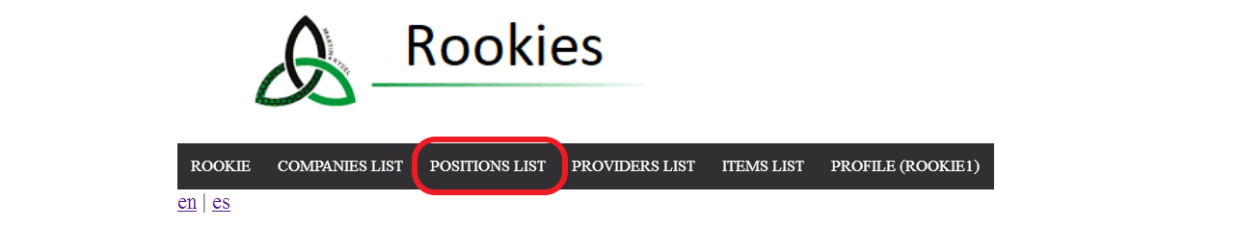
* Click on “Application” (english version) or “Solicitud” (spanish version) in the position with ticker “Wilk-7446”.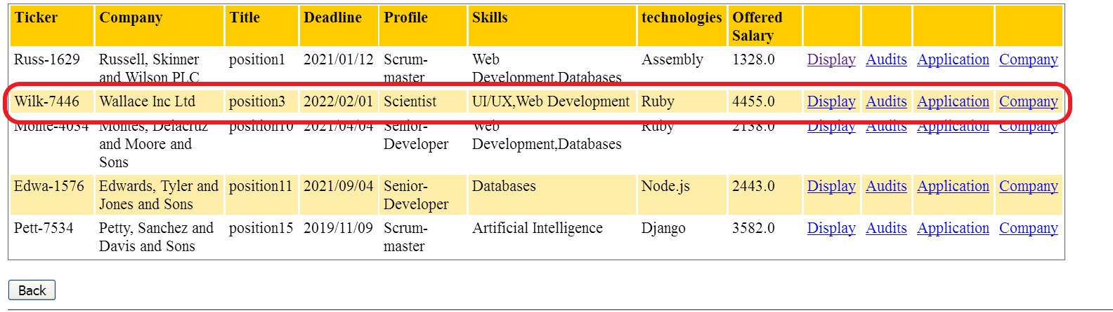

#### 

#### Tests

|  |  |
| --- | --- |
| Test <#1> | |
| **Description** | The form must be filled in with the following data: **Answer**: test, **Curriculum**: lorem ipsum. |
| **Expected** | The system back to applications list, and now you can see the new application. |
| **Outcome** |  |
| **Notes** |  |

|  |  |
| --- | --- |
| Test <#2> | |
| **Description** | The form must be filled in with the following data: **Answer**: <script>alert(‘Hola Mundo’)</script> (JavaScript), **Curriculum**: lorem ipsum. |
| **Expected** | The system back to create form with an “Insecure HTML” |
| **Outcome** |  |
| **Notes** |  |

### 

### 

### Use Case UC25 Rookie edits application

#### Description

An actor who is authenticated as a rookie must be able edit an application.

#### Access

* Login as rookie3/rookie3.
* Click on “Applications” (english version) and “Solicitudes” (spanish version).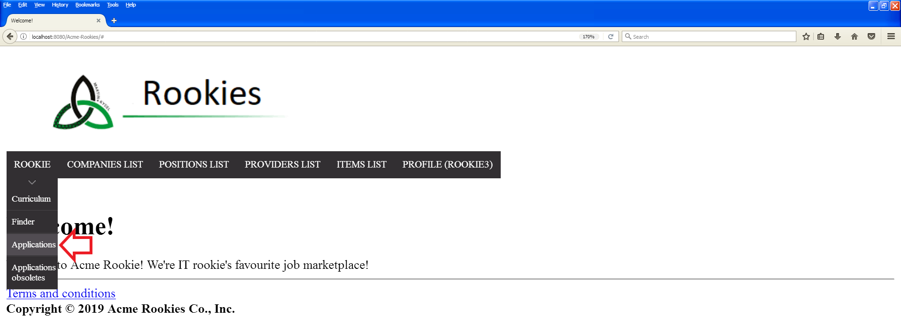
* Click on “Application” (english version) or “Solicitud” (spanish version) in the position with ticker “Wilk-7446”.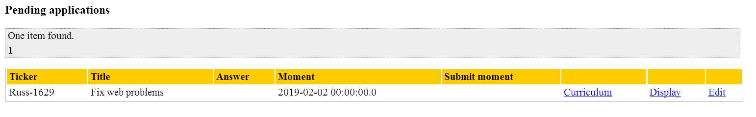
* Click on “Edit” or “Editar” in the application with ticker “Russ-1629”.

#### 

#### Tests

|  |  |
| --- | --- |
| Test <#1> | |
| **Description** | The form must be filled in with the following data: **Answer**: test, **Curriculum**: lorem ipsum. |
| **Expected** | The system back to applications list, and now you can see the new application. |
| **Outcome** |  |
| **Notes** |  |

|  |  |
| --- | --- |
| Test <#2> | |
| **Description** | The form must be filled in with the following data: **Answer**: <script>alert(‘Hola Mundo’)</script> (JavaScript), **Curriculum**: lorem ipsum. |
| **Expected** | The system back to create form with an “Insecure HTML” |
| **Outcome** |  |
| **Notes** |  |

### Use case UC26 Auditor assigns positions

#### Description

#### An actor who is **authenticated** as an Auditor must be able to self-assign a position. The actor should hit on “Assign position” button to see the list of available positions to self-assign. Then he or she should click on the “Assign position” button of the position that he or she wants to assign

#### Access

#### - Login as Auditor: auditor1/auditor1

#### - Hit on “Assign position” button

#### - Hit on “Assign position” button of the position you want to associate

#### 

#### 

#### 

#### 

#### Tests

|  |  |
| --- | --- |
| Test #1 | |
| **Description** | When you are seeing the list of available positions to self-assign, click on the “Assign position” button, of the position 3 for example. |
| **Expected** | The system must redirect you to the list of the positions that you have assigned. Now you can see that the position 3 is in list. |
| **Outcome** |  |
| **Notes** |  |

#### 

|  |  |
| --- | --- |
| Test #2 | |
| **Description** | When you are seeing the list of available positions to self-assign, click on the “Back” button. |
| **Expected** | The system must redirect you to the “Welcome page” |
| **Outcome** |  |
| **Notes** |  |

### Use case UC27 Auditor creates audits

#### Description

#### An actor who is **authenticated** as an Auditor must be able to creates an audit. The actor should hit on “My positions” button to see the list of available positions to audit. Then he or she should click on the “Audit” button of the position that he or she wants to audit.

#### Access

#### - Login as Auditor: auditor1/auditor1

#### - Hit on “My positions” button

#### - Hit on “Audit” button of the position you want to audit

#### 

#### 

#### 

#### 

#### 

#### 

#### 

#### Tests

|  |  |
| --- | --- |
| Test #1 | |
| **Description** | When you are seeing the list of available positions to audit, click on the “Audit” button, of the position 3 for example. Now fill the form fields with this data:  **Text**: ‘This is a sentence; many sentences are a paragraph.’  **Score**: ’10.0’,  **Final mode**: No final.  Click the save button. |
| **Expected** | The system must redirect you to the list of your audits. Now you can see your new audit created correctly. |
| **Outcome** |  |
| **Notes** |  |

#### 

#### 

#### 

#### 

#### 

#### 

#### 

#### 

|  |  |
| --- | --- |
| Test #2 | |
| **Description** | When you are seeing the list of available positions to audit, click on the “Audit” button, of the position 3 for example. Now fill the form fields with this data:  **Text**: ‘This is a sentence; many sentences are a paragraph.’  **Score**: ’11.0’,  **Final mode**: No final.  Click the save button. |
| **Expected** | The system must show an error due to the score should be in a range. |
| **Outcome** |  |
| **Notes** |  |

### Use case UC28 Auditor edits and deletes audits

#### Description

#### An actor who is **authenticated** as an Auditor must be able to edits and deletes his or her audits. The actor should hit on “My audits” button to see the list of his or her audits. Then he or she should click on the “Display” button of the audit that he or she wants to edit or delete (the audit must have false ‘Final mode’ to be modify). Finally he or she should click on the “Edit” button.

#### Access

#### - Login as Auditor: auditor1/auditor1

#### - Hit on “My audits” button and you should see the list of your audits

#### - Hit on “Display” button of the audit you want to edit or delete

#### 

#### - Hit on “Edit” button

#### 

#### Tests

|  |  |
| --- | --- |
| Test #1 | |
| **Description** | Before that you should see in the list of audits, all of your audits.  When you are seeing the “Display” view of your audit (with false ‘final mode’). Click on Edit button and change the Text field to: ‘This is my new edited audit’  Click the save button. |
| **Expected** | The system must redirect you to the list of your audits. Now you can see your new audit edited correctly. |
| **Outcome** |  |
| **Notes** |  |

#### 

|  |  |
| --- | --- |
| Test #2 | |
| **Description** | When you are seeing the “Display” view of your audit (with false ‘final mode’). Click on Edit button and change the Score field to: 11.0  Click the save button and you should see an error about the range of the score.  Finally click on the Cancel button. |
| **Expected** | The system must redirect you to the list of your audits correctly |
| **Outcome** |  |
| **Notes** |  |

### Use Case UC29 Admininistrator notifies new changes

#### Description

An actor who is authenticated as administrator must be able send notifications to the rest of actors.

#### Access

* Login as admin/admin.
* Click on “Messaging” button

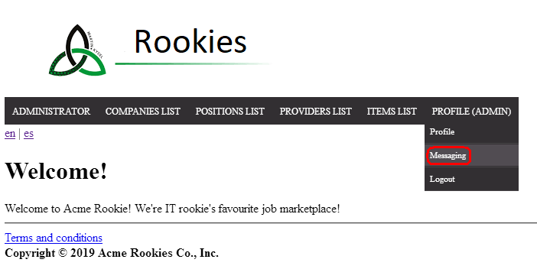

Tests

|  |  |
| --- | --- |
| Test <#1> | |
| **Description** | When you are seeing “Messaging” view, click the “Notify rebranding” button . |
| **Expected** | The system must show all notifications that have been send to all of actors. |
| **Outcome** |  |
| **Notes** |  |

### 

### 

### Use Case UC30 Administrator creates a new auditor

#### Description

An actor who is authenticated as a administrator must be able create user accounts for new auditors.

#### Access

* Login as admin/admin.
* Click on “Sign up auditor” (english version) or “Registrar auditor” (spanish version).

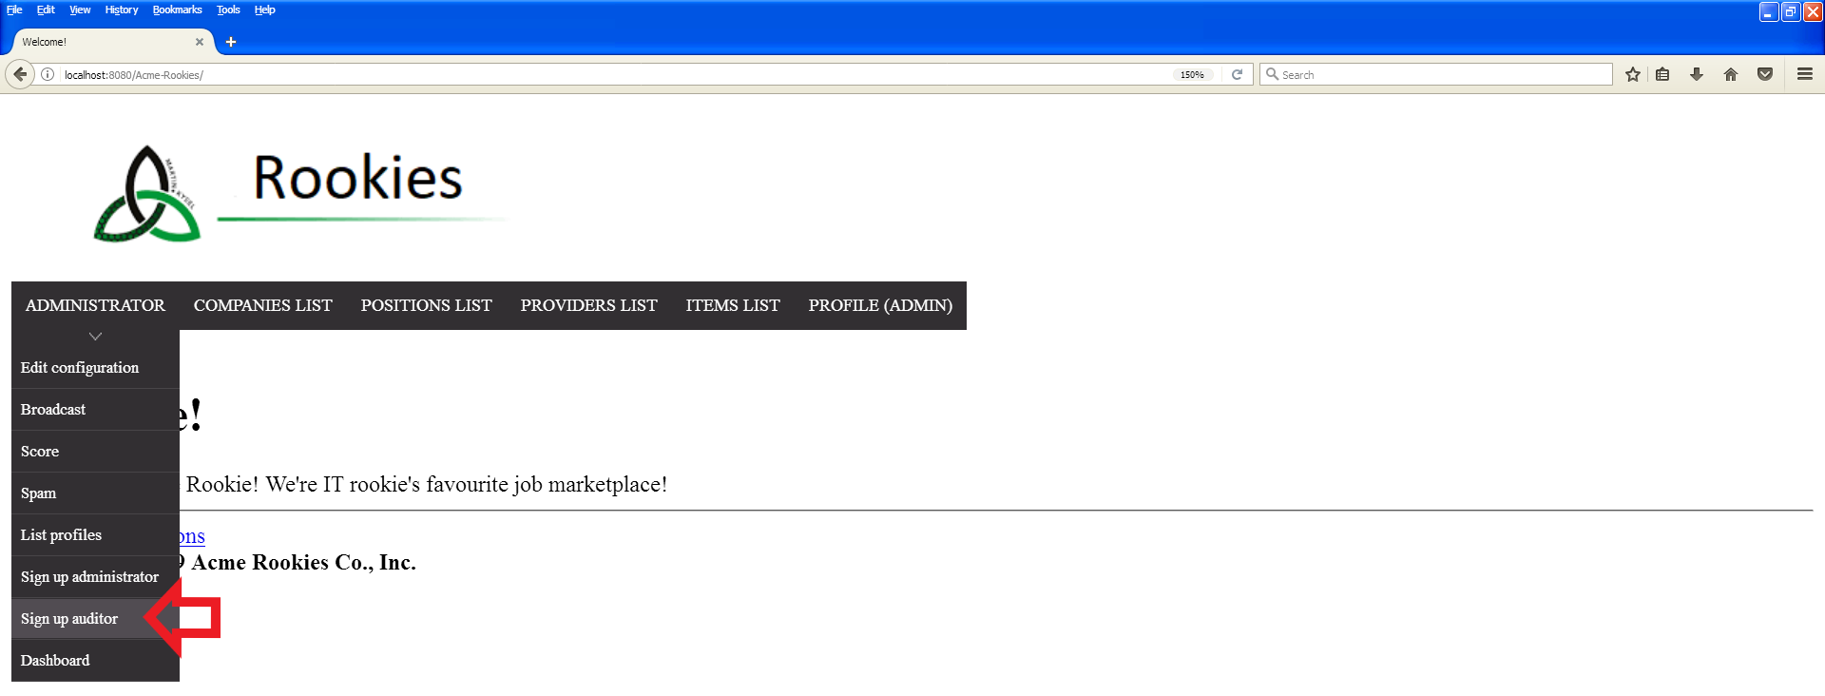

#### 

#### Tests

|  |  |
| --- | --- |
| Test <#1> | |
| **Description** | The form must be filled in with the following data: **Name**: Rubén Antonio, **Surnames**: Ramírez Rojas, **VAT**: 9056325, **Photo**: null, **Email**: [rubantramroj@gmail.com](mailto:rubantramroj@gmail.com), **Phone**: +34 678905413, **Address**: null, **Username**: auditorTest, **Password**: auditorTest, **Confirm Password**: auditorTest, **Holder Name**: Rubén Antonio Ramírez Rojas, **Make**: Visa, **Number**: 4556737586899855, **Expiration Month**: 11, **Expiration Year**: 2021, **CVV**: 904, **I read and accept terms and conditions**. |
| **Expected** | The system back to welcome page. |
| **Outcome** |  |
| **Notes** | It’s import to repopulate the database in order to avoid repetitions in the attributes. |

|  |  |
| --- | --- |
| Test <#2> | |
| **Description** | The form must be filled in with the following data: **Name**: Rubén Antonio, **Surnames**: Ramírez Rojas, **VAT**: 9056325, **Photo**: null, **Email**: [rubantramroj@gmail.com](mailto:rubantramroj@gmail.com), **Phone**: +34 678905413, **Address**: null, **Username**: auditor1 (repeated username), **Password**: auditorTest, **Confirm Password**: auditorTest, **Holder Name**: Rubén Antonio Ramírez Rojas, **Make**: Visa, **Number**: 4556737586899855, **Expiration Month**: 11, **Expiration Year**: 2021, **CVV**: 904, **I read and accept terms and conditions**. |
| **Expected** | The system back to create form with an “Error”. |
| **Outcome** |  |
| **Notes** |  |

### Use Case UC31 Actor not authenticated sees all the items of the system

#### Description

An actor who is not authenticated access to the item’s list.

#### Access

* Go to item’s list

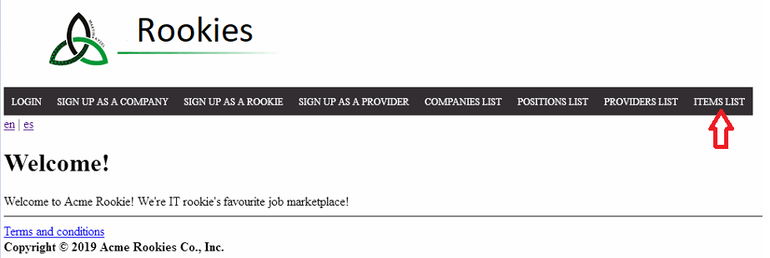

#### Tests

|  |  |
| --- | --- |
| Test #1 | |
| **Description** | Click on the **back** button. |
| **Expected** | The system redirects you to the **welcome page.** |
| **Outcome** |  |
| **Notes** |  |

|  |  |
| --- | --- |
| Test #2 | |
| **Description** | Click on the **provider** button of a item |
| **Expected** | The system redirects you to the **provider display** of the item’s owner. |
| **Outcome** |  |
| **Notes** |  |

### 

### 

### 

### 

### 

### 

### 

### 

### Use Case UC32 Actor not authenticated see all the providers of the system

#### Description

An actor who is not authenticated access to the provider’s list.

#### Access

* Go to provider’s list

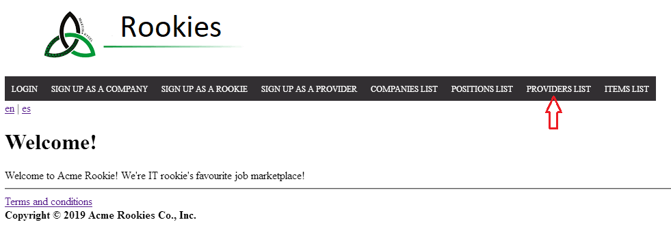

#### Tests

|  |  |
| --- | --- |
| Test #1 | |
| **Description** | Push the **back** button. |
| **Expected** | The system redirects you to the **welcome page.** |
| **Outcome** |  |
| **Notes** |  |

|  |  |
| --- | --- |
| Test #2 | |
| **Description** | Push the **Items** button of a provider |
| **Expected** | The system redirects you to the **items list** that this provider is the **owner**. |
| **Outcome** |  |
| **Notes** |  |

### Use Case UC33 Provider creates item

#### Description

An actor who is authenticated as provider must be able create items.

#### Access

* Login as provider1/provider1.
* Click on “My items” button

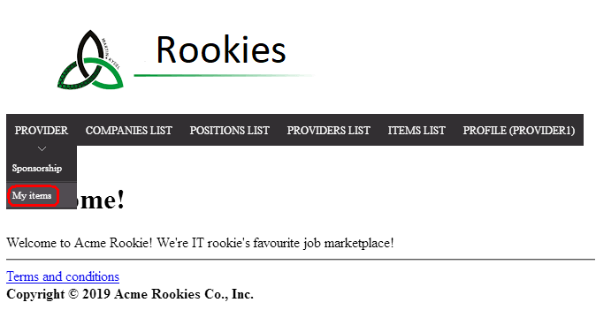

* Click on “Create” button

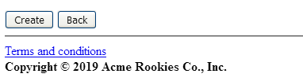

Tests

|  |  |
| --- | --- |
| Test <#1> | |
| **Description** | When you are seeing “Create item” view, fill the form fields with this data:  **Name:** Item test  **Description:** Item for test  **Link:** http://itemTest.com  Click the save button |
| **Expected** | The system must redirect you to the list of items. Now you can see the new item created correctly. |
| **Outcome** |  |
| **Notes** |  |

|  |  |
| --- | --- |
| Test <#2> | |
| **Description** | When you are seeing “Create item” view, get the form fields empty  Click the save button |
| **Expected** | The system must show an error due to these fields must not be blank |
| **Outcome** |  |
| **Notes** |  |

### 

### 

### 

### 

### 

### 

### 

### Use Case UC34 Providee edits item

#### Description

An actor who is authenticated as provider must be able edit items.

#### Access

* Login as provider1/provider1.
* Click on “My items” button



* Click on “Edit” button of an item. For example this:

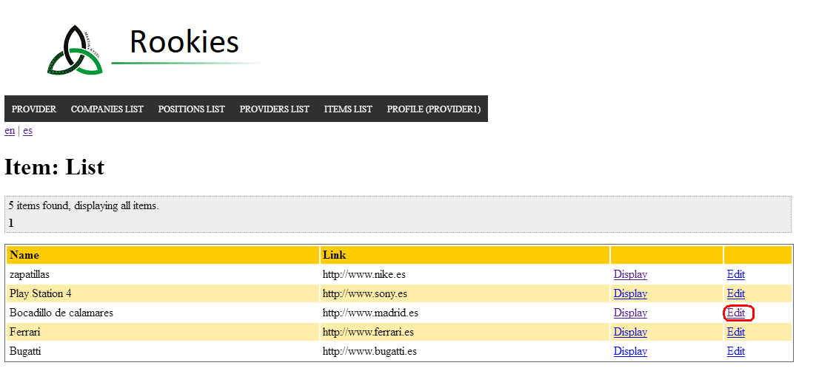

Tests

|  |  |
| --- | --- |
| Test <#1> | |
| **Description** | When you are seeing “Edit item” view, change the value of field **Name** to “Bocadillo de chicharrones”  Click the save button |
| **Expected** | The system must redirect you to the list of items. Now you can see the field of this item edited correctly. |
| **Outcome** |  |
| **Notes** |  |

|  |  |
| --- | --- |
| Test <#2> | |
| **Description** | When you are seeing “Edit item” view, change the value of itemId, in url page. Change id value to a non-exists id, for example, “1”  Push enter. |
| **Expected** | The system must redirect you to a view where says you that this id is not valid. |
| **Outcome** |  |
| **Notes** |  |

### Use case UC35 Provider creates sponsorship

#### Description

#### An actor who is **authenticated** as an Provider must be able to creates an sponsorship. The actor should click on “Position List” button to see the list of available positions to sponsor. Then he or she should click on the “Sponsor” button of the position that he or she wants to sponsor.

#### Access

#### - Login as Auditor: provider1/provider1

#### - Click on “Position List” button

#### 

#### - Click on “Sponsor” button of the position you want to sponsor.

#### 

#### 

#### 

#### 

#### Tests

|  |  |
| --- | --- |
| Test #1 | |
| **Description** | Click on the sponsor button of either position with the ticker Russ-1629 or Wilk-7446. |
| **Expected** | Since this provider already sponsor this position, the system must redirect you to the edit of that one (the fields of the edit have data on them). |
| **Outcome** |  |
| **Notes** |  |

#### 

#### 

#### 

#### 

#### 

#### 

#### 

|  |  |
| --- | --- |
| Test #2 | |
| **Description** | When you are seeing the list of available positions to audit, click on the “Audit” button, of the position with ticker Monte-403. Now fill the form fields with this data:  **Banner**: <http://test.es>’  **Target**: <http://test.es>’  **Holder name**: ’Paco’,  **Make**: ‘VISA’.  **Number**: 4929575666495339.  **Exp month**: 12.  **Exp year**: 2020.  **CVV**: 168.  Click the save button. |
| **Expected** | The system must create the sponsorship correctly. |
| **Outcome** |  |
| **Notes** |  |

### 

### 

### 

### 

### 

### 

### 

### Use case UC36 Provider edits and deletes sponsorship

#### Description

#### An actor who is **authenticated** as an Provider must be able to edit and delete an sponsorship. The actor should click on “Sponsorships” button to see the list of their sponsorships. Then he or she should click on the “edit” button of the sponsorhip that he or she wants to edit or delete.

#### Access

#### - Login as Auditor: provider1/provider1

#### - Click on “Sponsorships” button

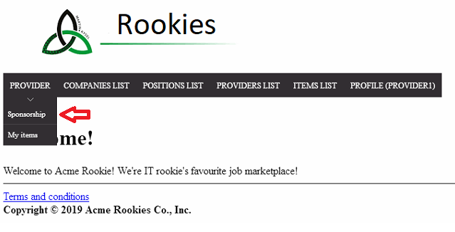

- Click on “Edit” button of the sponsorship you want to edit or delete.

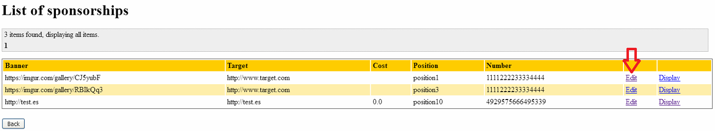

#### 

#### 

#### Tests

|  |  |
| --- | --- |
| Test #1 | |
| **Description** | Click on the edit button of the sponsorship of the position 1 for example. Then delete it clicking on ‘delete’. |
| **Expected** | The system must redirect you to the list of sponsorships and now there’s one less sponsorship on the list (the one you just deleted). |
| **Outcome** |  |
| **Notes** | In the image there’s two sponsorship due to the previous test. |

#### 

|  |  |
| --- | --- |
| Test #2 | |
| **Description** | Click on the edit button of the sponsorship of the position 3 for example. Now fill the form fields with this data:  **Banner**: https://imgur.com/gallery/RBIkQq3  **Target**: http://www.target.com’  **Holder name**: provider1,  **Make**: ‘VISA’.  **Number**: 1111222233334444.  **Exp month**: 10.  **Exp year**: 2018.  **CVV**: 355.  Click the save button. |
| **Expected** | The system must show an unexpected error due to the credit card expiration date is over. |
| **Outcome** |  |
| **Notes** |  |

### 

### 

### 

### 

### Use Case UC37 Administrator makes a decision for application

#### Description

An actor who is authenticated as a company must be able make a decision for her/his applications.

#### Access

* Login as company1/company1.
* Click on “Applications” (English version) or “Solicitudes” (Spanish version).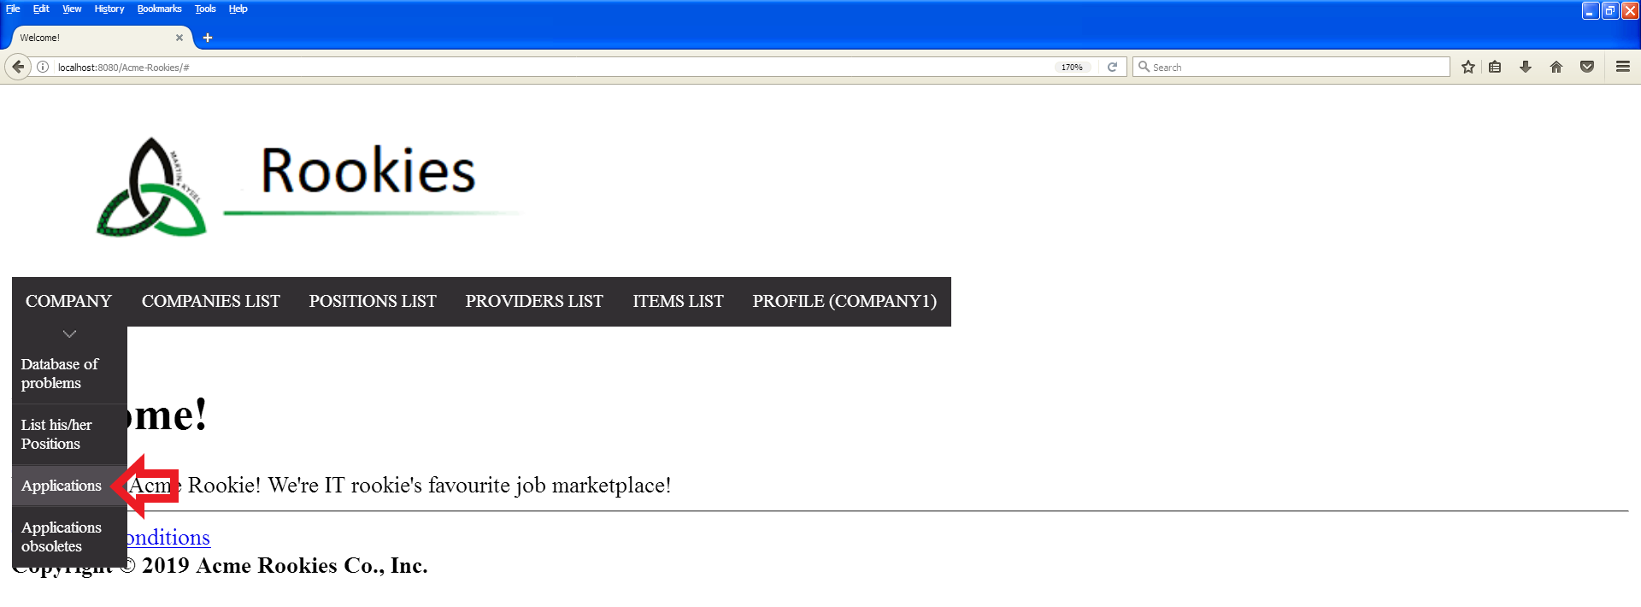
* Scroll down to see the application with position’s ticker “Russ-1629” and problem’s problem “Mobile app” in “Submitted applications”.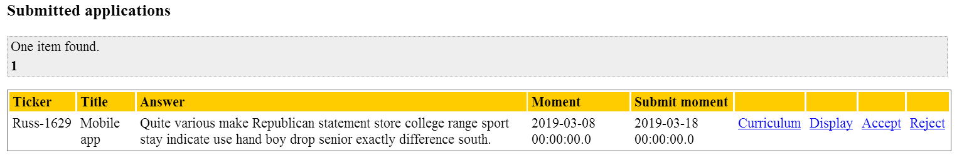

#### 

#### Tests

|  |  |
| --- | --- |
| Test <#1> | |
| **Description** | Accept the application with position’s ticker “Russ-1629” and problem’s title “Mobile app”. |
| **Expected** | The system back to applications list. The accepted application appears in “Accepted applications”. |
| **Outcome** |  |
| **Notes** | It’s import to repopulate the database so that the applications appears in “Submitted applications”. |

|  |  |
| --- | --- |
| Test <#2> | |
| **Description** | Reject the application with position’s ticker “Russ-1629” and problem’s title “Mobile app”. |
| **Expected** | The system back to applications list. The accepted application appears in “Rejected applications”. |
| **Outcome** |  |
| **Notes** | It’s import to repopulate the database so that the applications appears in “Submitted applications”. |

|  |  |
| --- | --- |
| Test <#3> | |
| **Description** | Performs Get hacking in the “reject” link with id 4724 **(the first pending application id).** |
| **Expected** | The system back to welcome page. |
| **Outcome** |  |
| **Notes** | Check that the id is correct. |

# Additional tests

|  |  |
| --- | --- |
| **Test #1** | |
| **Description** | Every actor can export his or her personal data. He or She should go to his or her profile and hint on “Export data button” |
| **Expected** | The system should generate a txt file with the correct information of the actor. |
| **Outcome** |  |
| **Notes** |  |